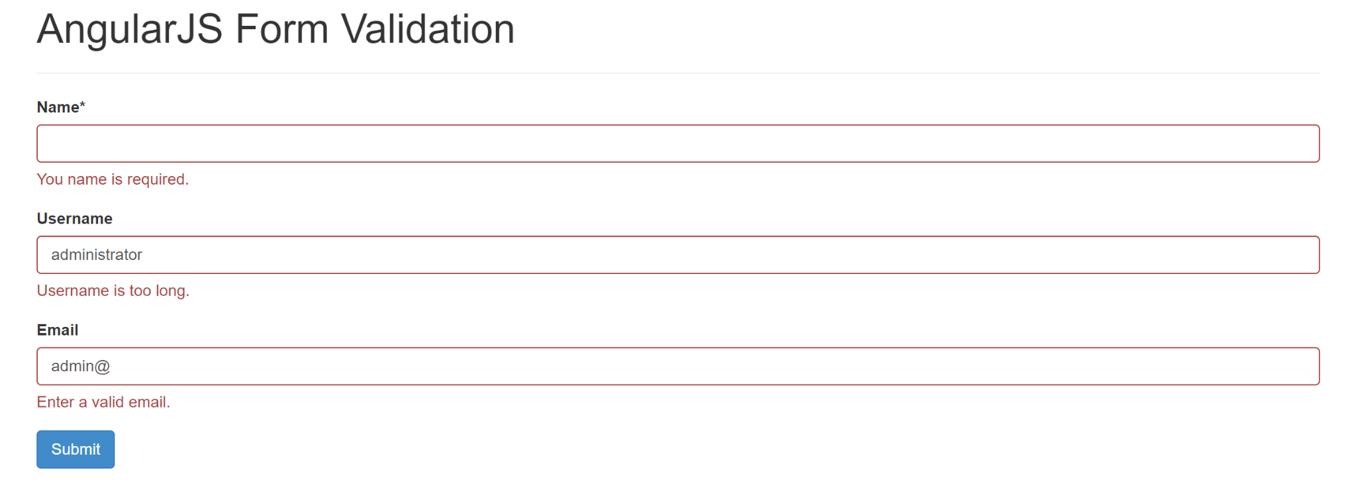

Cấu trúc project

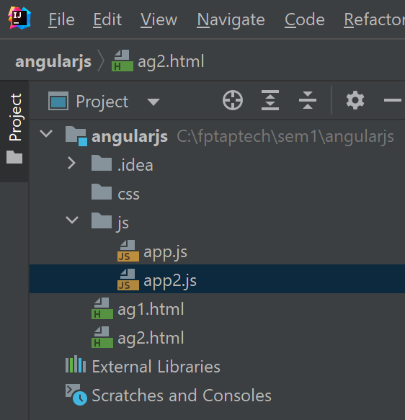

CDN

<script src="<https://ajax.googleapis.com/ajax/libs/angularjs/1.6.9/angular.min.js>"></script>

<link rel="stylesheet" href="//netdna.bootstrapcdn.com/bootstrap/3.0.3/css/bootstrap.min.css" />

***ag2.html***

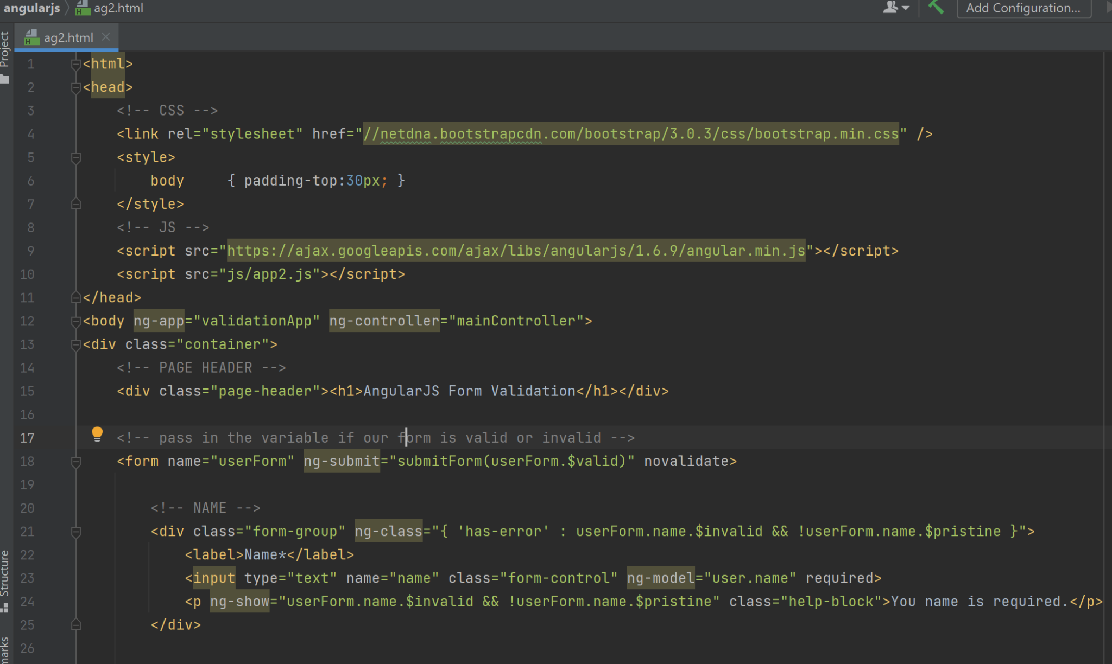

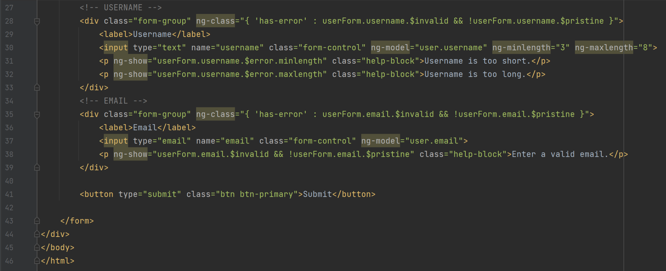

***app2.js***

